

**CCTV Image Captioning using Deep Learning**

Submitted By Amal KM

# Image Captioning using Deep Learning

Image captioning is a task that involves understanding and generating captions or descriptions for different images. This is based on two sub-tasks: Computer Vision and Natural Language Processing. It involves extraction of features from images using Convolutional Neural Networks (CNNs) and caption generation with Recurrent Neural Networks (RNNs). It includes meaningful and comprehensive textual descriptions of the image content. Feature extraction using CNN models such as VGG, DenseNet201, Inception and so on, is a key part of image captioning process. These networks are trained on large datasets (e. g., ImageNet) and can detect complex patterns, as well learn hierarchical features in images. The last few layers of the CNN usually output a feature vector that contains information regarding what is in the image and this will serve as the building block for generating caption. Once the features have been derived, they are passed into a sequence generation model. These models are well-suited to address temporal dependencies, meaning that they perform great on tasks where data is sequential such as in time-series problems. We also perform both image and text pre-processing to make the models more efficient and well performing. These pre-processing steps make sure the data can be used as an input of suitable format for our deep learning models which help in enhancing its performance and accuracy. Integrating pre-processing for images and text, CNNs for feature selection, RNNs etc form one of the base architecture design deep learning approach for image captions which helps machines to say words from pictures with great knowledge each day.

## Problem statement

CCTV cameras create a massive amount of CCTV cameras create a massive amount of visual data, which is difficult and labor-intensive to observe manually for people 24/7. Automated analysis and description of the content in surveillance images are essential to make these CCTV cameras more efficient and effective. This project aims to develop a deep learning model that automatically generate descriptive captions (descriptions) of images from CCTV cameras. It also helps in real-time analysis and live captioning of surveillance footage, in order that safety operators can watch occasions as they occur and determine potential incidents immediately. The image captioning system provide automated summaries and descriptions to improve the efficiency of surveillance operations, freeing up human operators for events that truly matter. Through the development of a deep learning model that creates descriptive captions for CCTV images and is run automatically, this project looks to transform surveillance systems, increasing security at lower costs.

### Benefits of Image captioning using Deep Learning

Image Captioning using Deep Learning has many key benefits. Some of them are:

﻿1. Accessibility: Image captions help increase the accessibility of online media for visually impaired persons by providing text descriptions over images that otherwise would leave many people struggling to understand or interact with digital content.

﻿2. Content Management - Help in content management, for example, automatically generating descriptive metadata to organize and manage vast numbers of images. Provides an interface so that it is easier to search, retrieve images with certain content.

﻿3. Improved User Experience: Image captioning improves user engagement, making image descriptions both relevant and contextually accurate in social media platforms and can be utilised for e-commerce purposes or digital marketing as an important element to the overall experience of users.

4. Streamlining Processes: By automating the tagging and annotation of images, valuable time and resources can be saved, particularly beneficial for managing datasets across industries such as media, retail and digital libraries

5. Clearer Communication: The ability to provide precise descriptions of images enhances communication serving purposes in news reporting, educational materials and interactive narratives.

6. Global Reach: Sophisticated image captioning models can now generate captions in languages facilitating engagement, with audiences worldwide.

7. Efficient Search Functionality: With descriptive captions attached to images users can now easily search for visuals based on textual queries improving the efficiency of image retrieval processes.

#### Dataset Used

For building the automated image captioning model, we used Flickr8K dataset. This dataset contains up to 5 captions for each images. The total number of images present in this dataset is 8091 and also their respective captions. The total file size of this dataset is 1.05 GB.

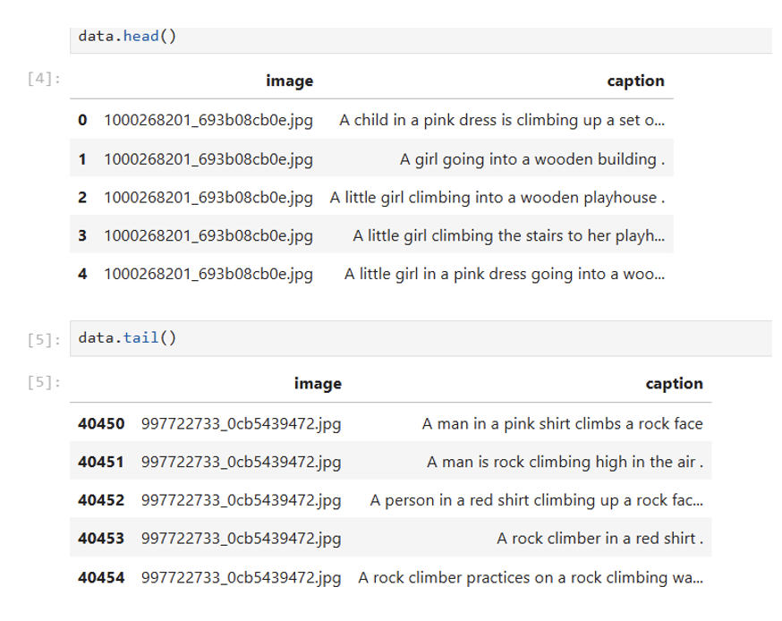

##### Methodology

* **Data Collection and Preparation**
* **Data Pre-processing**
* **Model Architecture Design**
* **Model Training**
* **Evaluation**
* **Fine-Tuning and Hyperparameter Tuning**
* **Deployment**

###### Data Pre-processing

**Text Pre-processing**

It involves cleaning and preparing the captions or descriptions for building the model.

Some of the techniques used include converting to lower case, removing stop words, removing numbers, removing punctuations and special characters, removing tags and URLs and so on. Stemming and Lemmatization can also be used as a part of text pre-processing.

**Image Pre-processing**

It involves cleaning, resizing and normalizing images before used as an input. This helps the model to understand and study the images better. Normally, we normalize the images and resize them to a consistent shape (e.g. 224x224 pixels).

Code and results of both text and image pre-processing are shown below.

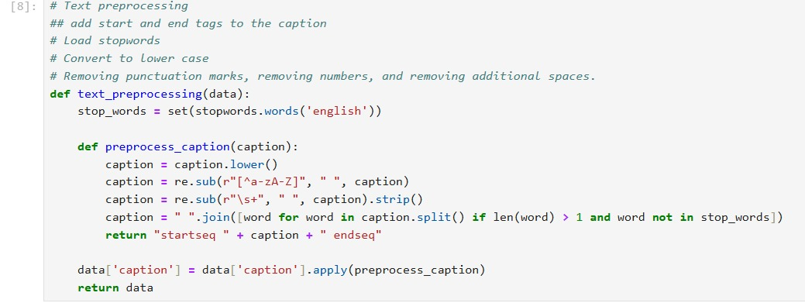

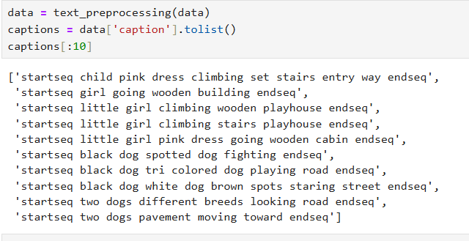

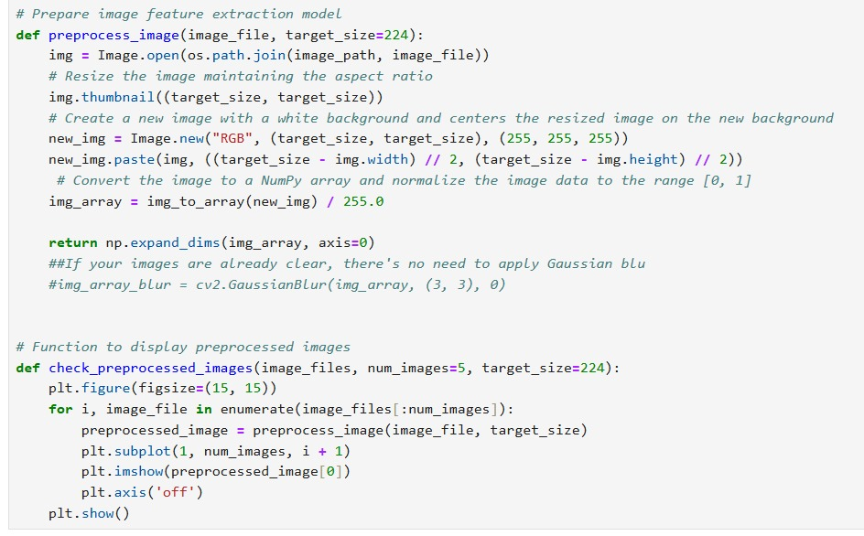

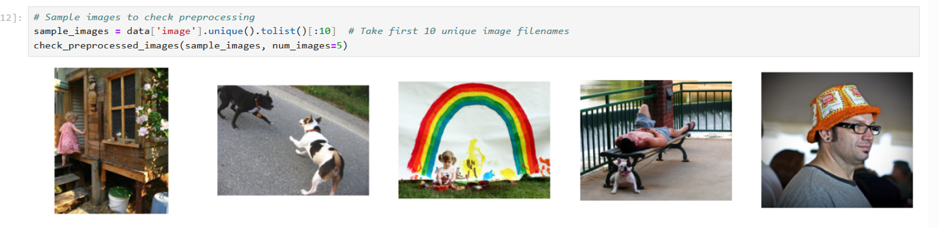

Model Architecture Design

Before building the model, we split the dataset for training, testing and validation.

Training Dataset: Assign 70% of the data, for training purposes. This portion is essential for teaching the model enabling it to grasp the features and patterns for creating captions.

Validation Dataset: Reserve 10% of the data for validation purposes. This segment comes into play during training to refine the model and choose the model based on validation loss and other criteria.

Testing Dataset: Set aside 20% of the data for testing purposes. This segment is utilized only after the model has been fully trained to assess its performance, on data.

Once we split the data, we then start with model architecture.

I created a model involving a combination of both CNN for image feature extraction and RNN(specifically LSTM) for sequence generation. It has 3 parts: encoder, sequence model and decoder. Also, compiled the model and used optimizer ‘Adam’. 2 models were created and fine-tuned 2nd model for better performance.

Code and results are shown below.

Loading necessary libraries

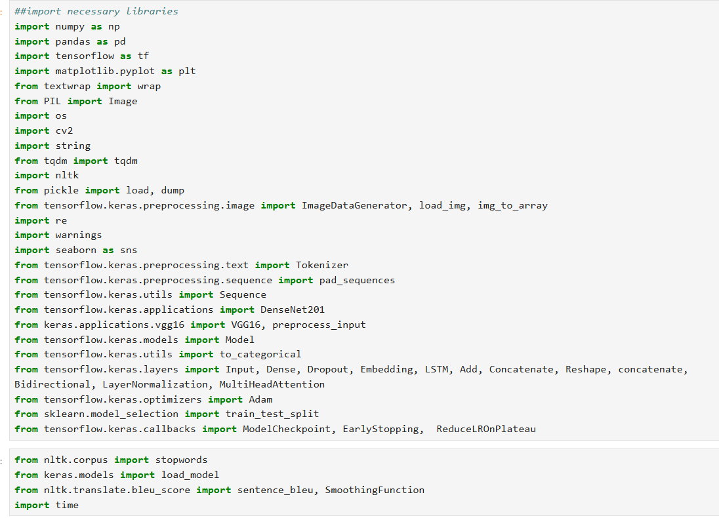

Loading the dataset

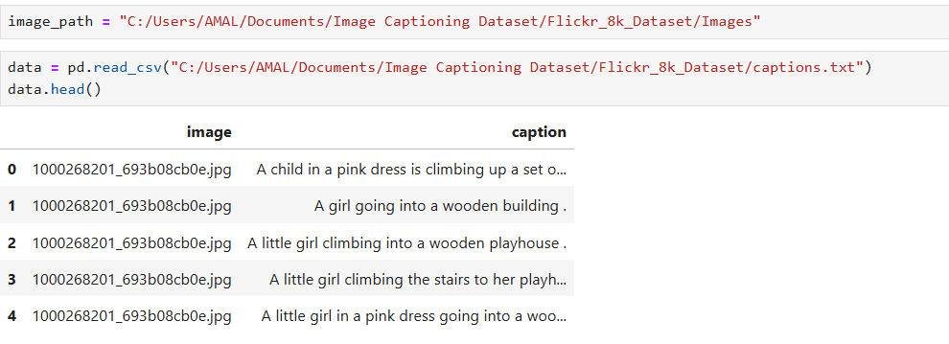

Splitting the dataset

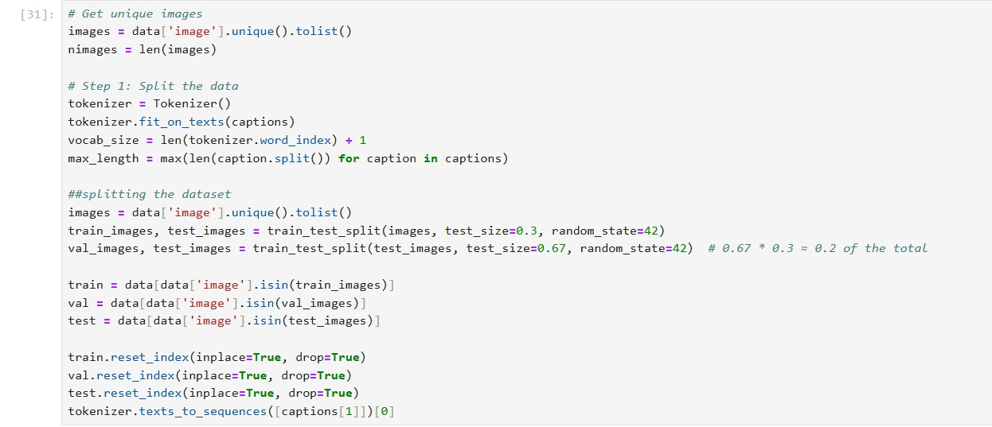

Data generator: It helps in loading data in batches and ensuring efficient memory usage.

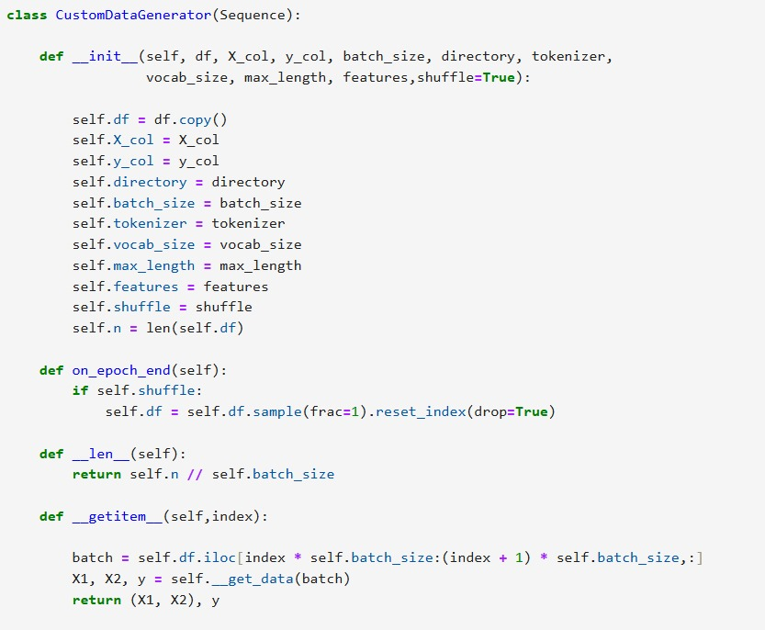

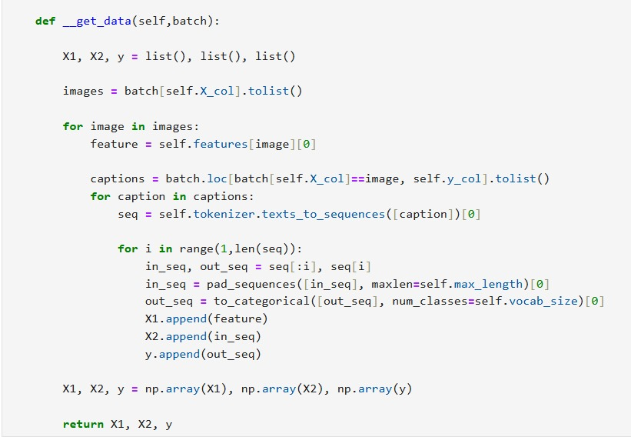

Model-1

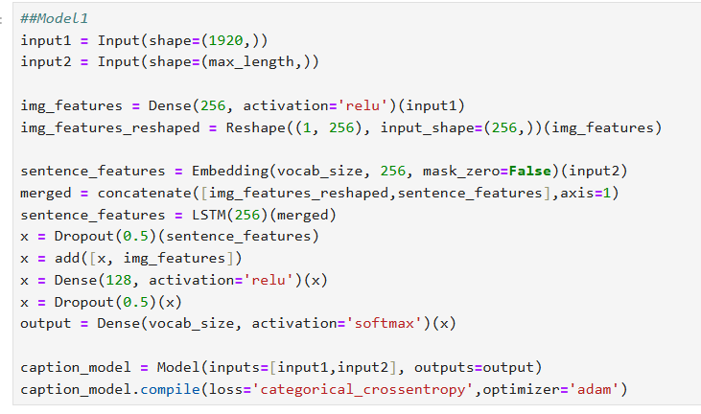

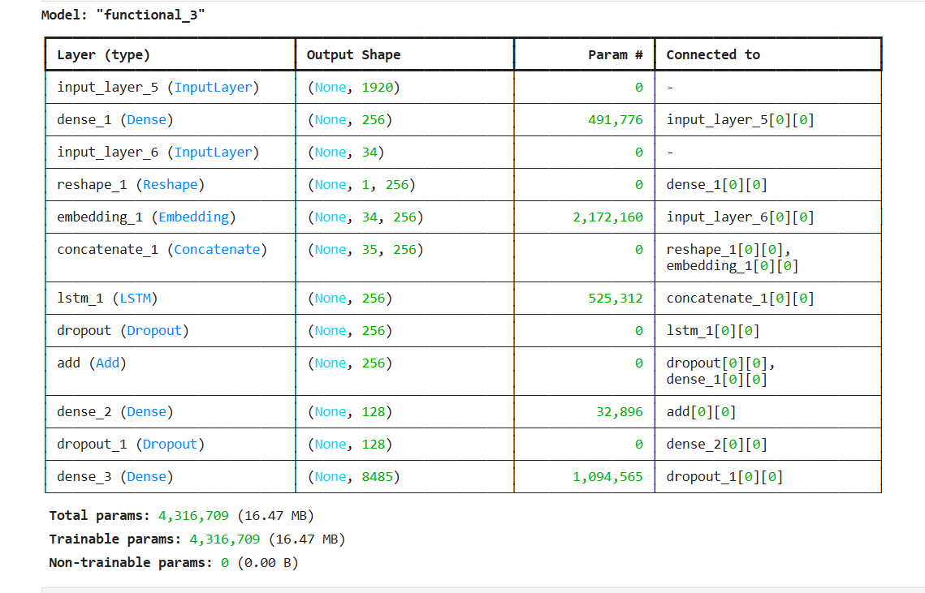

Creating data batches and defining checkpoint callback

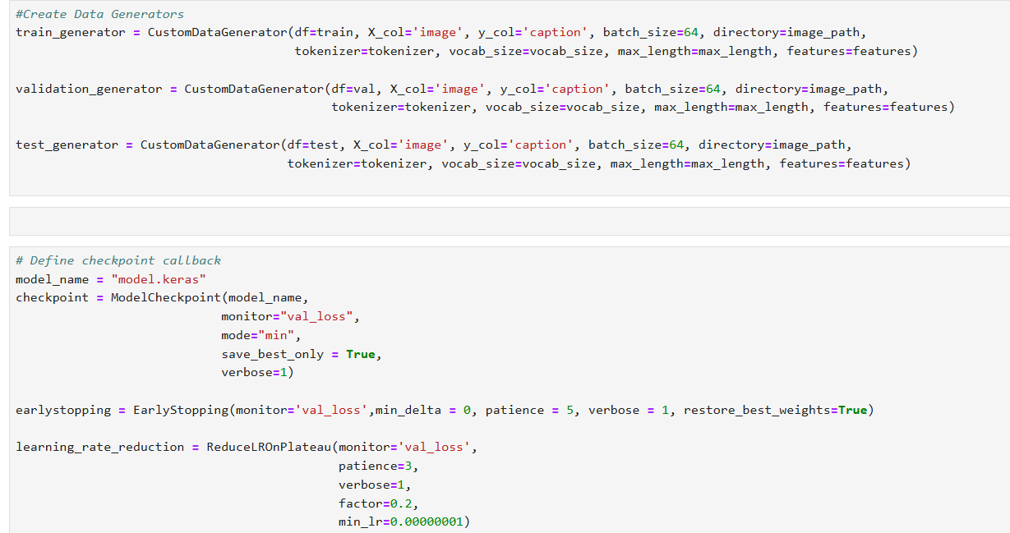

Training Model-1

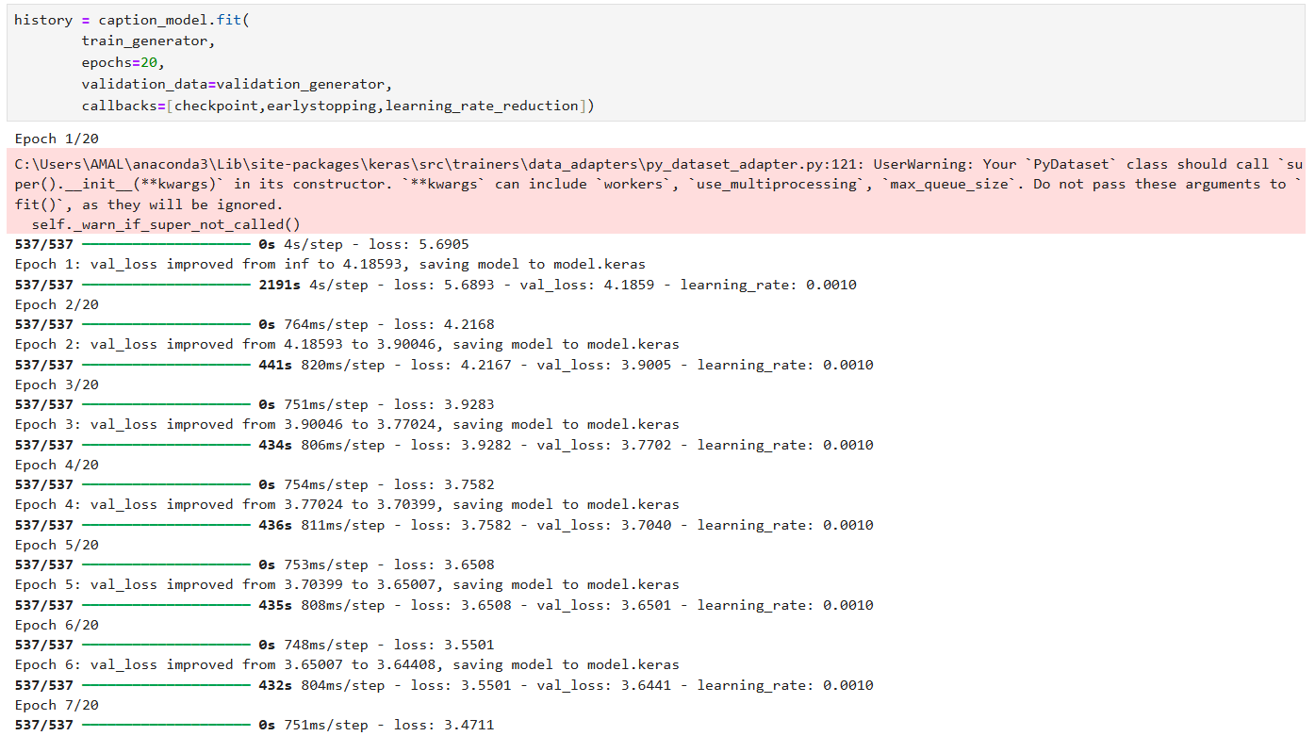

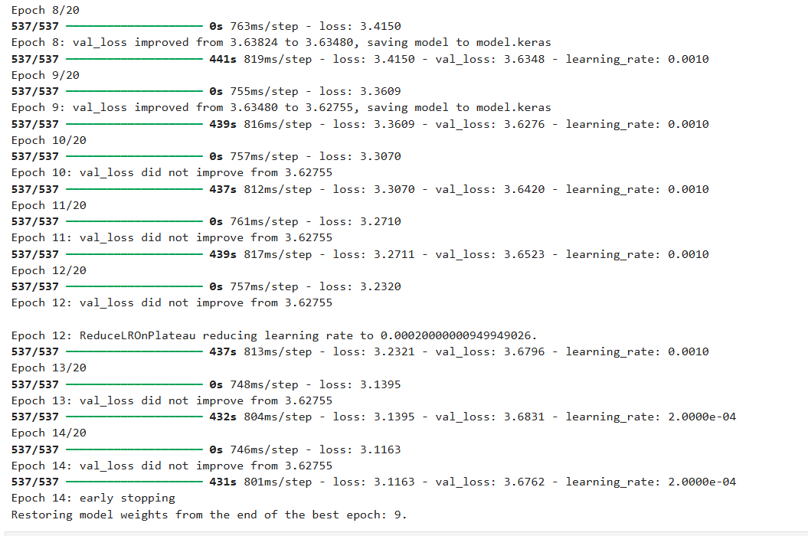

Creating model loss vs epochs plot

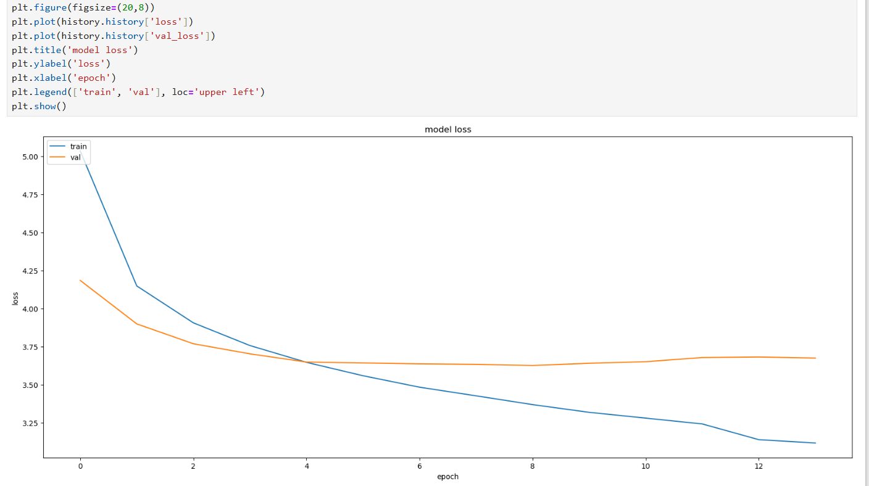

Model-1 Prediction

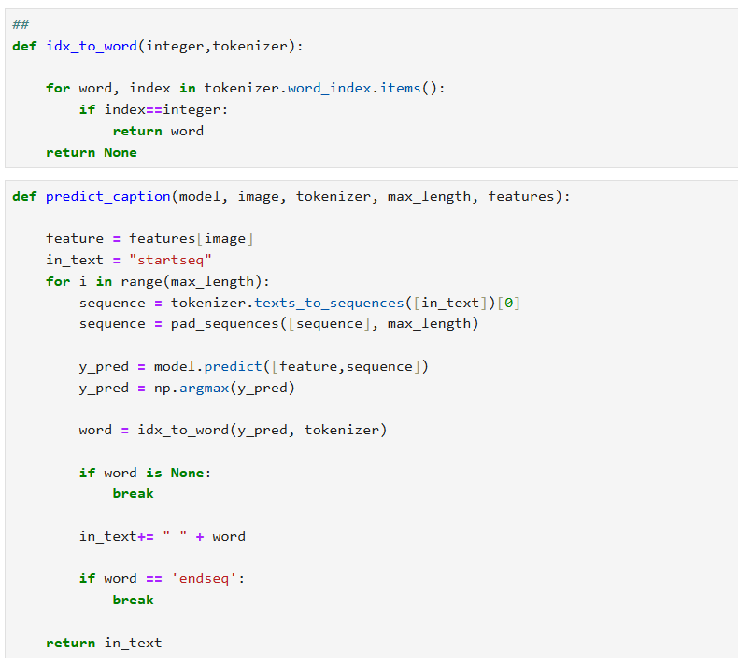

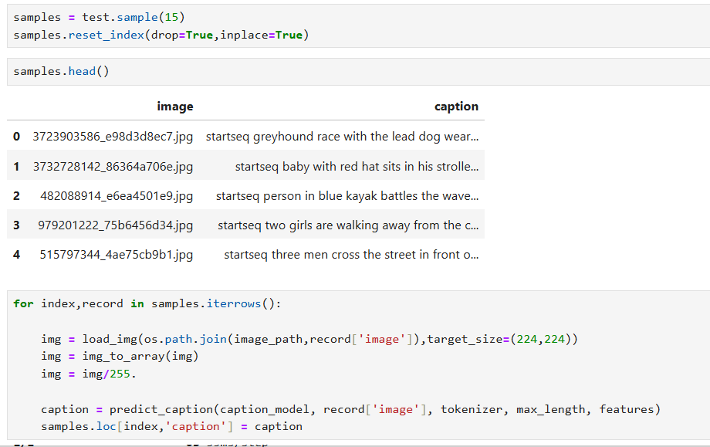

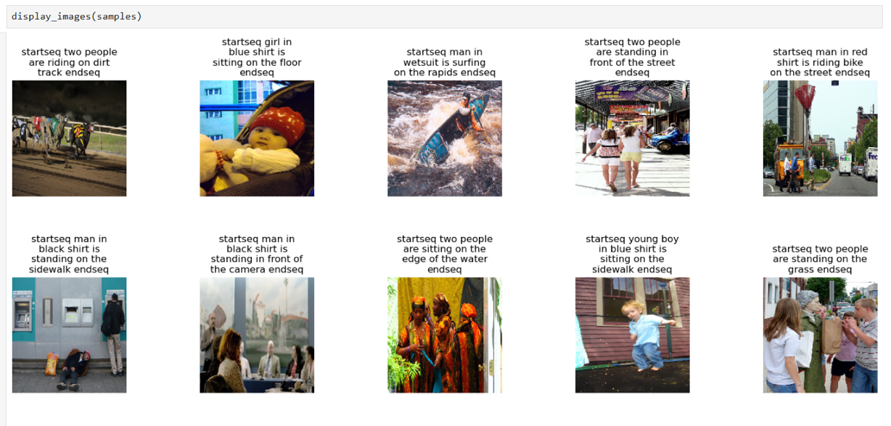

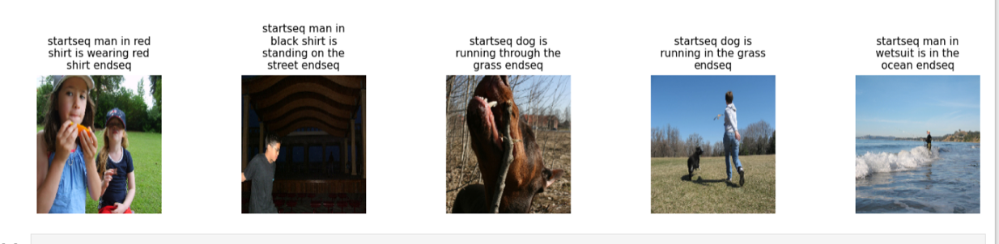

Model-2

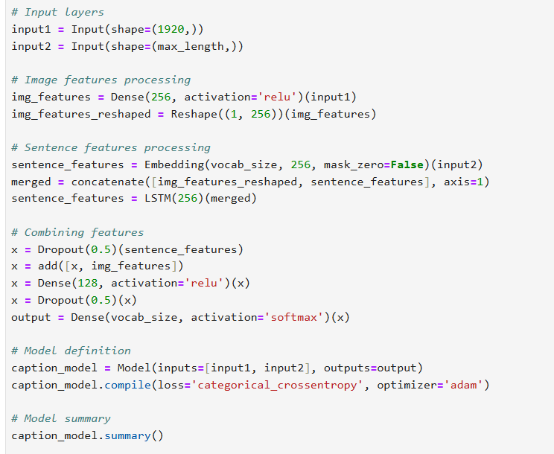

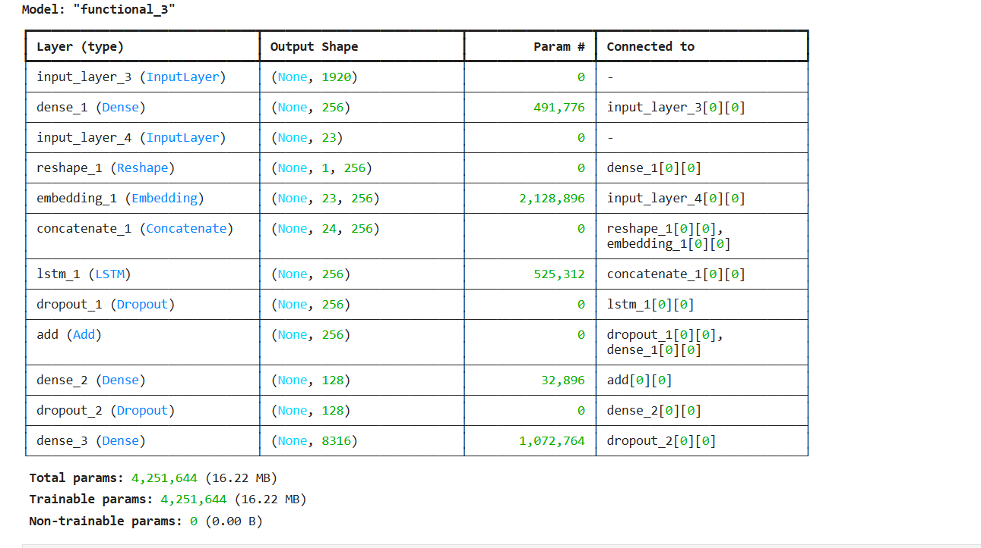

Model-2 training

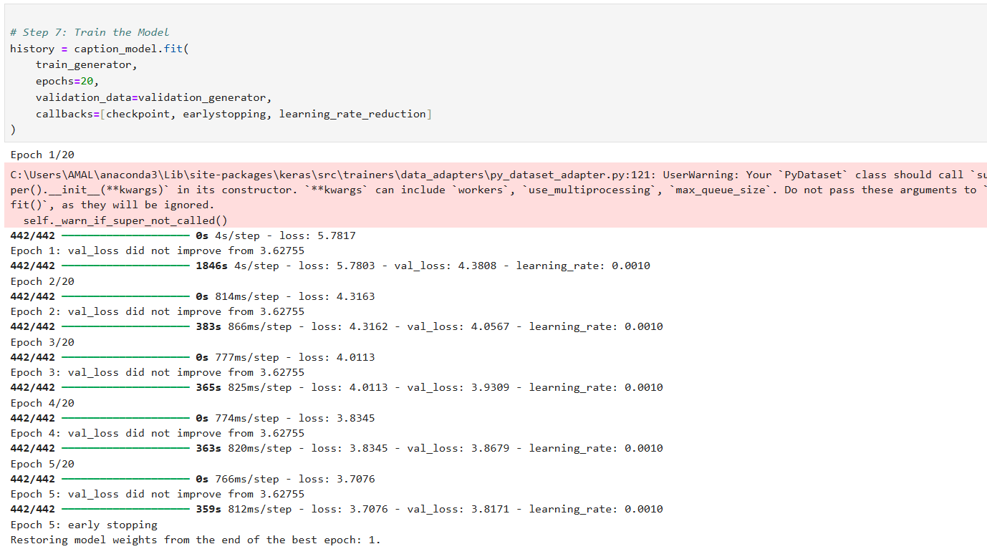

Model-2 Plot

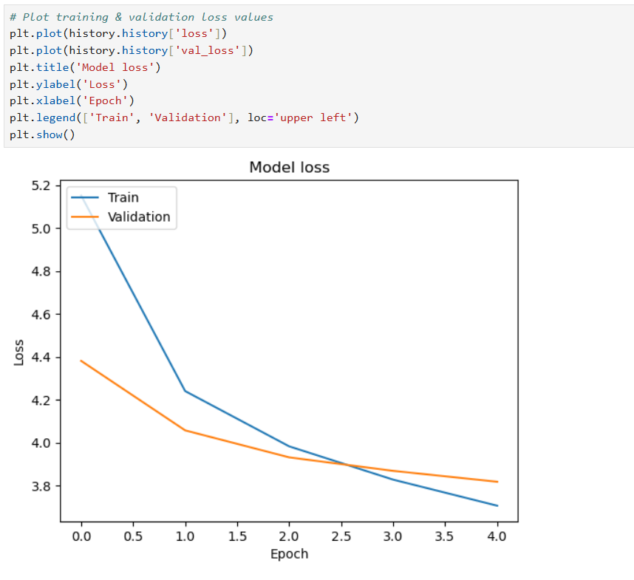

Model-2 Prediction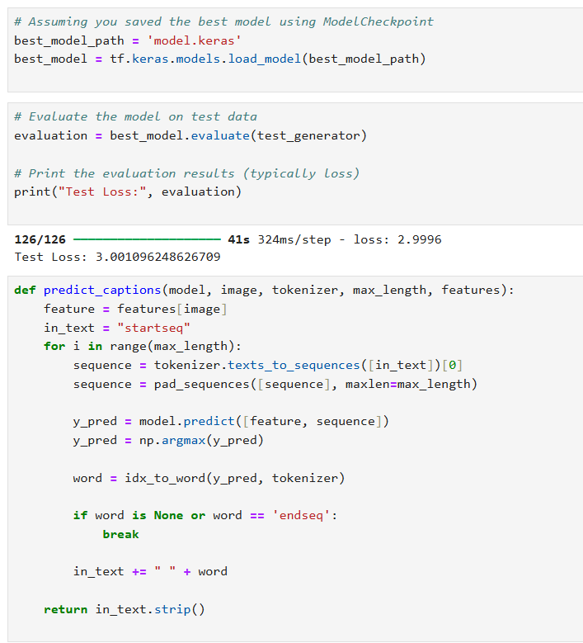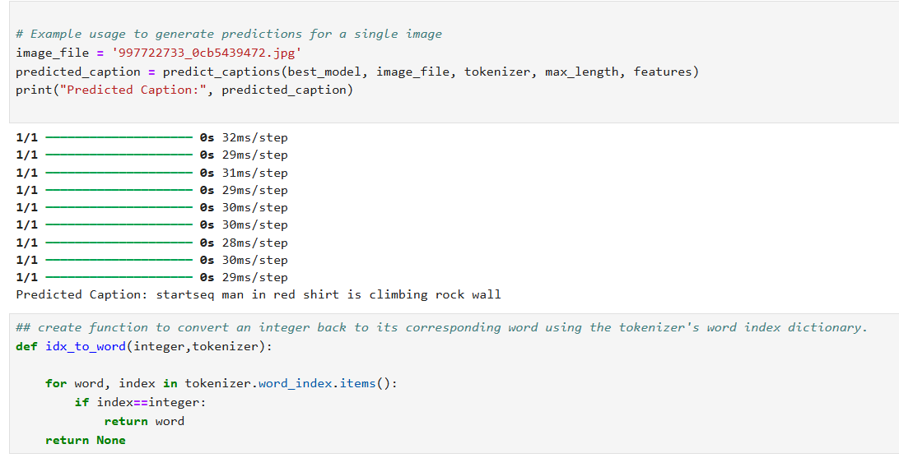

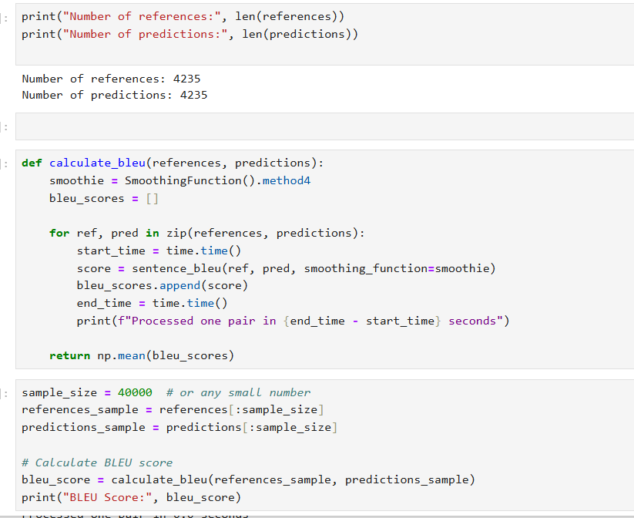



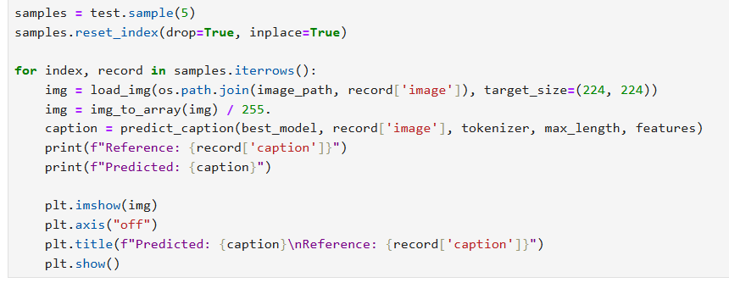

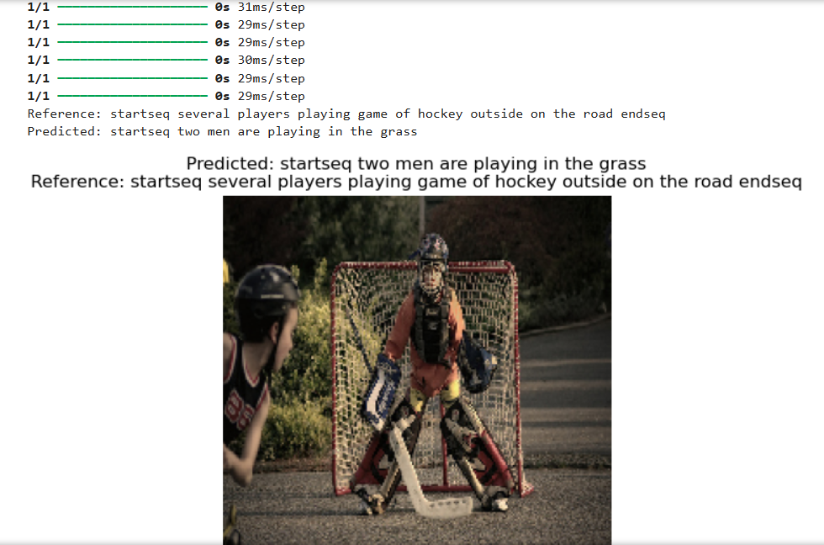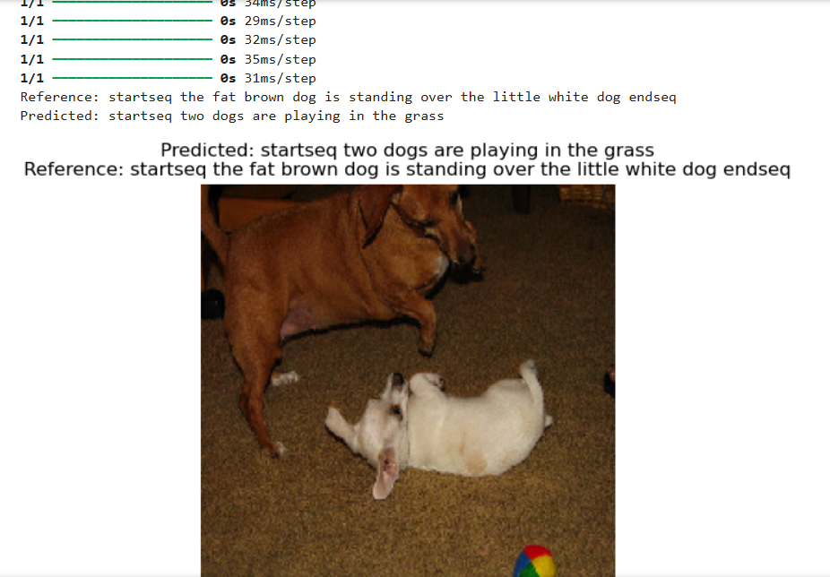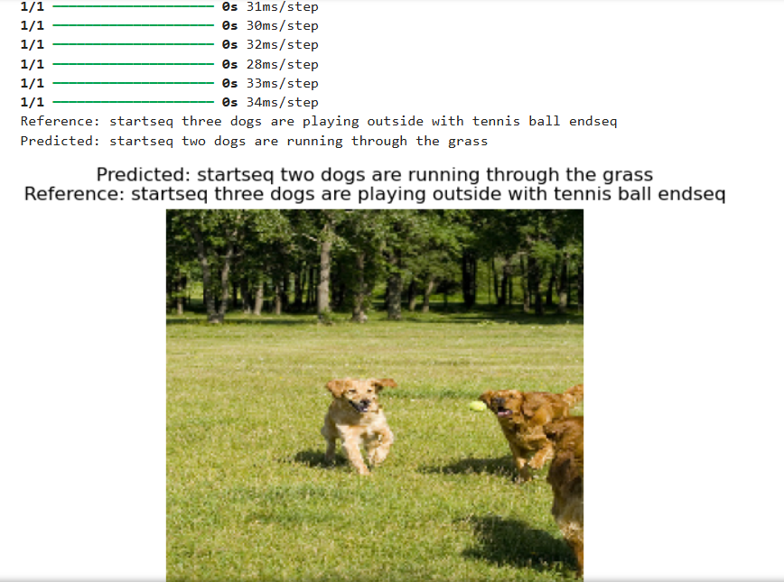

Fine-Tuning

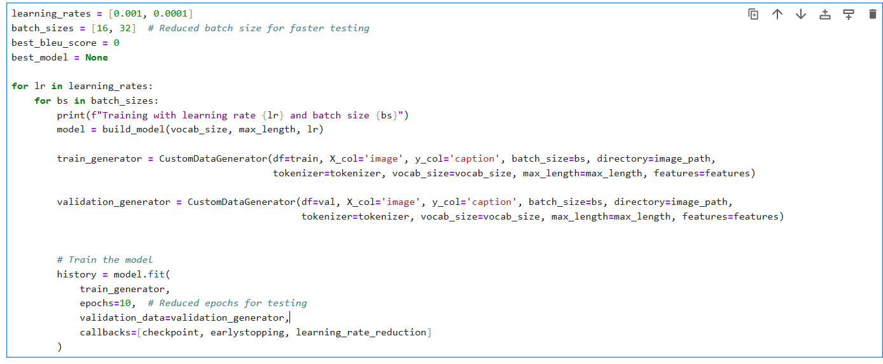

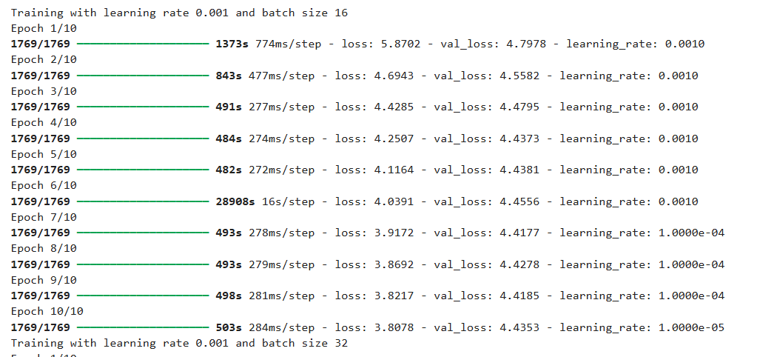

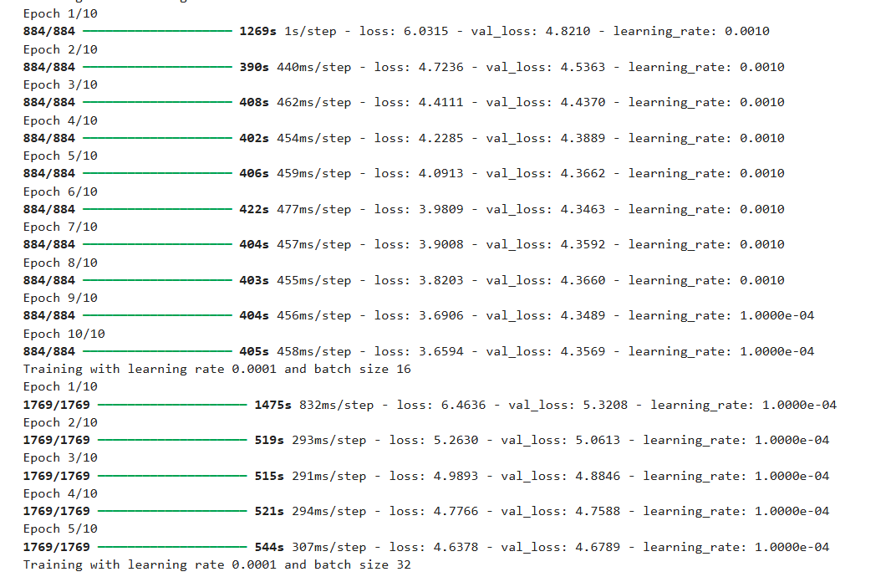

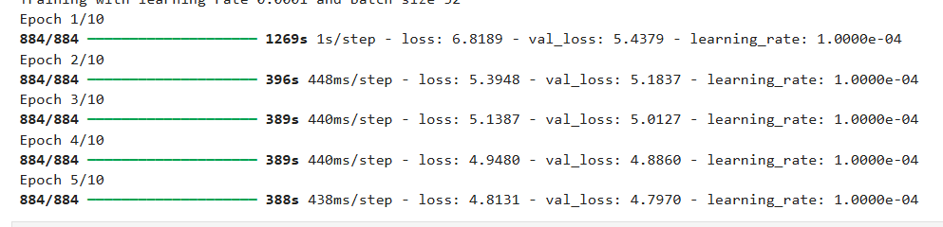

Training Plot

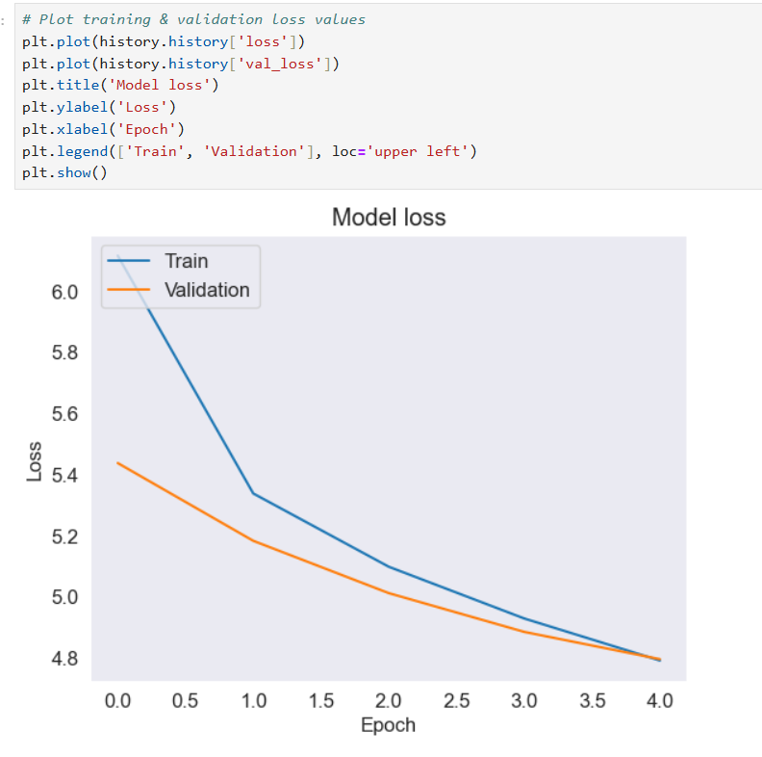

Model prediction

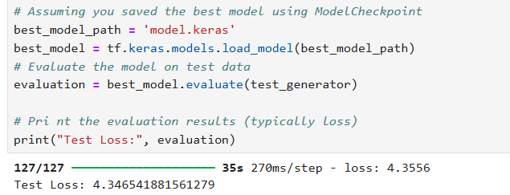

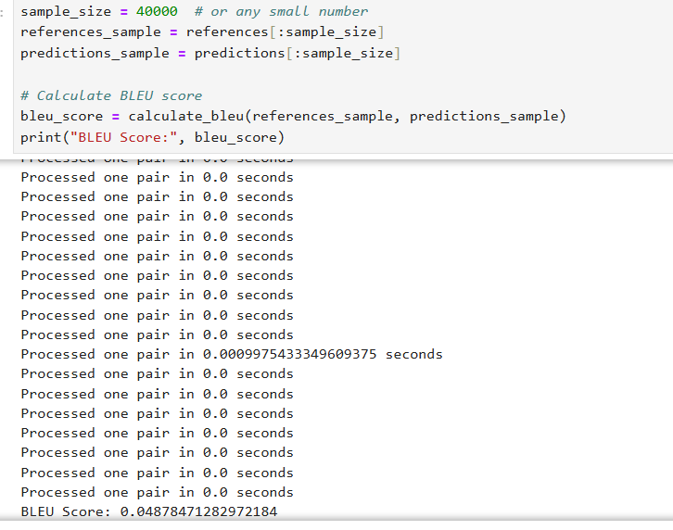

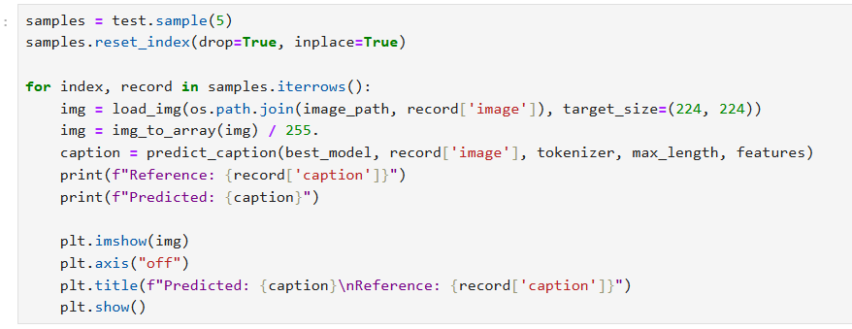

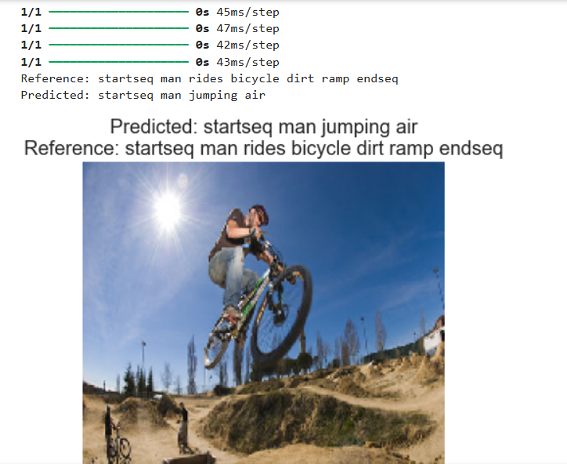

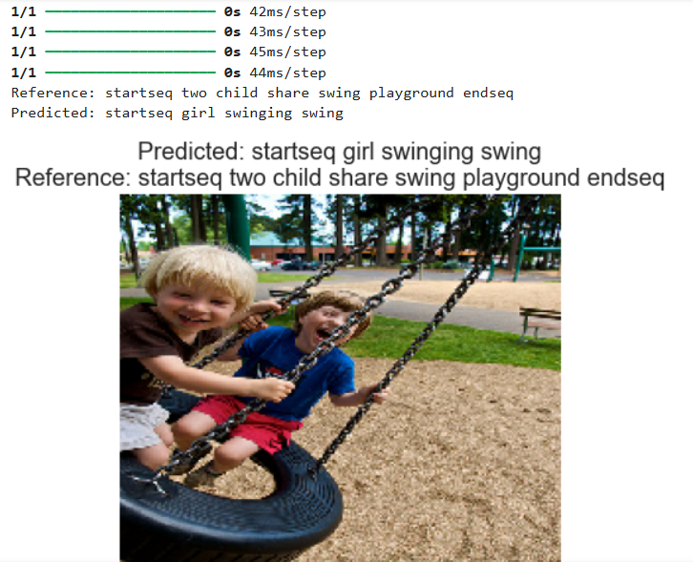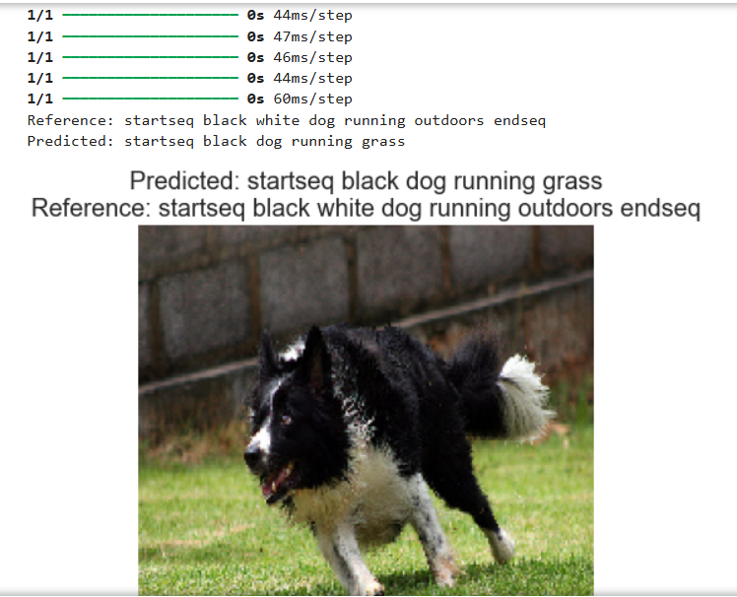

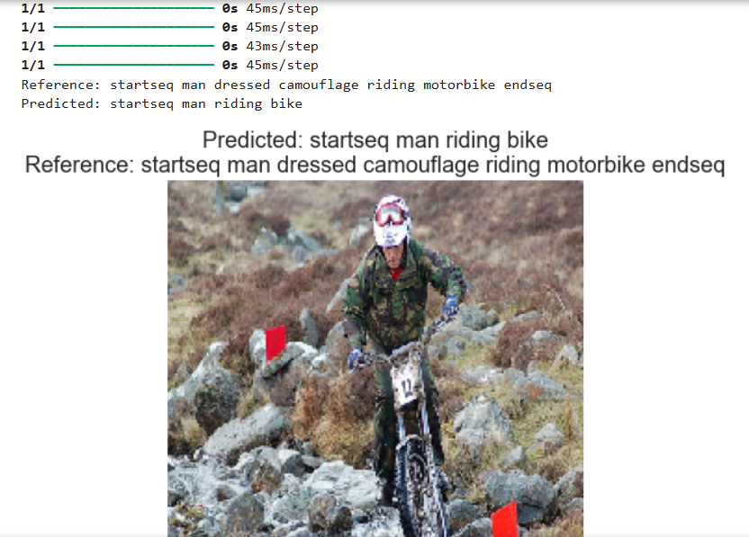

Results

Two models for image captioning have been created and assessed using deep learning methods. Both Model-1 and Model-2's loss numbers and BLEU scores show that they perform at various levels. Model-2 had a greater model loss of 4.34654188 and a BLEU score of 0.0487847128, whereas Model-1 attained a model loss of 3.00109624 and a BLEU score of 0.06005285994. These measurements offer a thorough understanding of how well each model generates pertinent and correct captions.

Performance of Model-1:

Model Loss: 3.00109624

BLEU Score: 0.06005285994

Outcome: With a greater BLEU score and a lower loss, Model-1 performs better. This suggests that it is more successful in producing captions that closely resemble actual true captions, more correctly capturing the images' context and details.

Performance of Model-2:

Model Loss: 4.34654188

BLEU Score: 0.0487847128

Outcome: A bigger loss and a lower BLEU score suggest that Model-2 is performing worse. This implies that the model might not be as good at accurately producing textual descriptions and capturing the subtleties of the photos.

Some of the results of both model are given below:

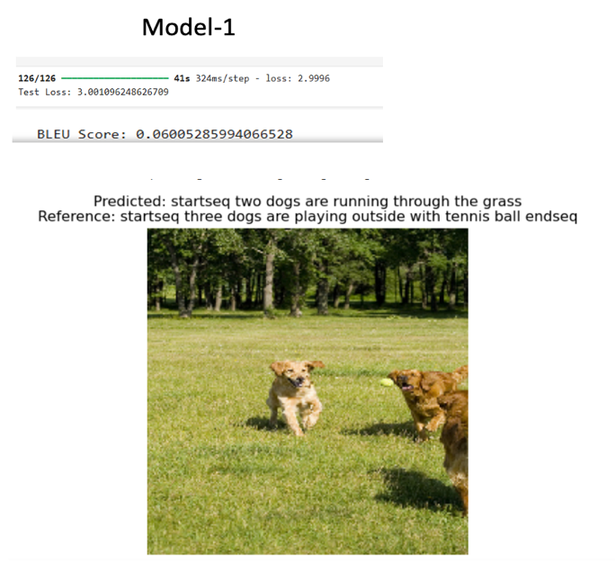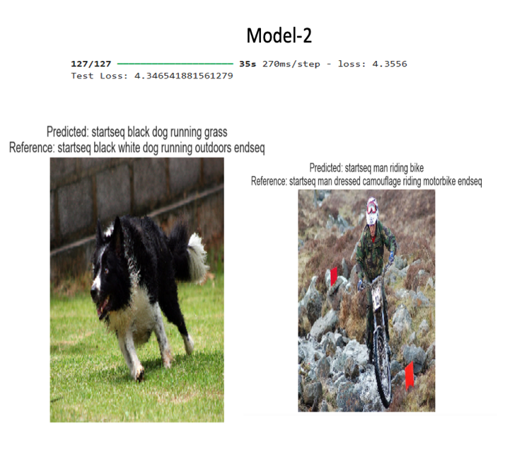

Future Prospects and Recommendations

Advancements in learning techniques are pushing the boundaries of image captioning research. Future studies may aim to enhance model accuracy and contextual comprehension work with a range of datasets and explore multimodal strategies that merge image, audio and text data, for more detailed descriptions. Even though the models were able to predict and generate captions according to the images, the results were not that sound. Based on the bleu score and test loss, this may not be the best performing model, but this project helps to understand how image captioning problems can be approached. Use of more powerful pretrained CNN model for feature extraction can help to increase efficiency. Incorporating a feedback loop can help to improve performance iteratively. Fine tuning models using transfer learning techniques can also help in this case. Use of a larger dataset can also help models generalize better across various domains and fields. These are some of the recommendations that can be implemented to create a more accurate and efficient image captioning models.

Conclusion

Deep learning-based image captioning is a major advancement in the way machines comprehend and describe visual input. It fills the void between visual data and human language by automating the creation of meaningful captions, offering useful applications, and expanding the potential of many technologies. The potential for increasingly more complex and precise image captioning models will grow as deep learning technology develops, presenting new opportunities and advantages in a variety of fields. The technology for image captioning will become more widely applicable as a result of these developments, providing richer and more complex descriptions that increase efficiency, improve accessibility, and offer deeper insights across a range of areas. The advancement of image captioning will be fueled by ongoing study and development in deep learning and multimodal approaches, which will open new possibilities for growth and improvements in the years ahead.